Software Testing

Movie Database

David Kelly – B00060572
David Malone – B00060176

Simon McLoughlin

Institute Of Technology Blanchardstown

Introduction
We decided to use non-incremental testing, this means, we tested each module individually and then put the entire program together and tested it. We used White-Box Testing and Black-Box Testing. White-Box Testing refers to when we test the product to see if, internally, it works according to the specification. Black-Box Testing refers to when we test the product to see if it performs the way it's supposed to.

What We Tested
We tested the GUI class, the DatabaseEngine class and the System class, as these tree are the main backbone of the entire program. We tested the main functions in each class, for DatabaseEngine.java these were: connect() and disconnect() and for System.java these were: searchMovies() and getMoviePage(). We tested these functions using BBT cases and WBT cases.

Test Cases
Testing DatabaseEngine.java:
The test case we used to test DatabaseEngine.java:
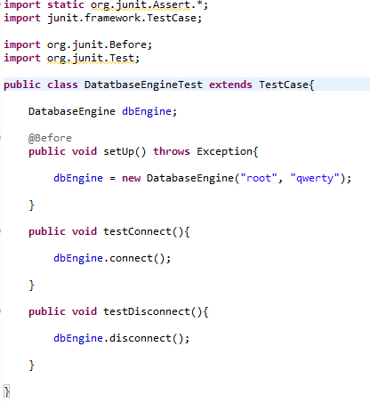

The test case we used to test System.java:
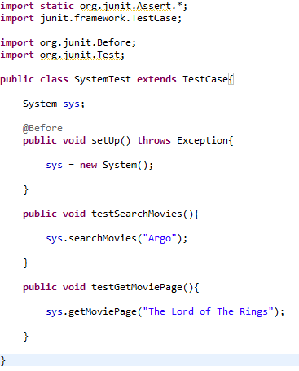

When we ran both of these tests we got varying results. With DatabaseEngineTest.java, the testConnect() method executed without interruption whereas the testDisconnect() method returned a NullPointerException from the line “connection.close();”, attempts were made to figure why this was happening but the results were inconclusive. With SystemTest.java the testSearchMovies() method executed without interruption, but the testGetMoviePage() method resulted in error. This is because the search string had a lower case letter where there should have been an upper case letter. To counter this we changed the sql statement to disregard the case of the letters, results will now be found when lower and upper case letters are used in the search string.

Regression Testing
When we performed the regression test we discovered that the change we made to the sql string affected searching for users, to fix this we make both sql statements separate strings so each could be tailored to the specific needs of each search function. There were no further errors in this section.

System Testing
Stress Test:
For the stress test we built a for loop to add 1000 entries to the database. The program crashed at around 500 entries and we were forced to restart the program. Aforementioned for loop:
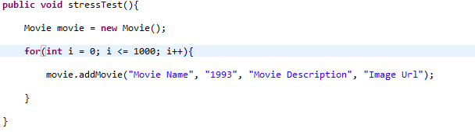
To fix this issue we add a timer of 10 mili seconds between each data entry, this allowed the system to keep up with the entries.

Volume Test:
The volume test did not result in error as the hard drive the database is on has 1tb of storage which is sufficient for our needs.

Usability Test:
While doing the usability test we discovered that it was difficult for some users to navigate away from pages, this was because all navigation was through a file menu in the top left corner of the GUI which is unconventional. We also discovered that some of the messages that were outputted by the system were somewhat cryptic at times so some users found them to be difficult to understand. In some cases there was a lack of acknowledgement when something was input into the system leaving the user unsure as to whether the action was successful or not.

Installation Test:
While no installation is needed for the program to function, the user is required to have the Java Runtime Environment installed to run the program. When the program did not work for some users it was difficult for them to figure out why it didn't work.

Acceptance Testing
When the acceptance tests were performed it was discovered that some of the functions that were originally specified in the design were not fully functioning, in this case the acceptance test was unsuccessful. This program did not fully function to the required standard.

